Directions: Solve the following systems of equations by graphing.
$y+1=−3x+4$ $y=2x−7$ $2−4x=−2y$ $y+8=3x+4$

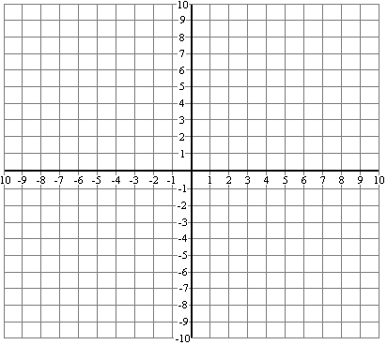

$x=$__________ $y=$__________ $x=$__________ $y=$__________

$2y−\text{12}=4x−\text{10}$ $3y=6x−\text{12}$ x – y = -3 $x+2y=−6$

$x=$__________ $y=$__________ $x=$__________ $y=$__________

